**Lab 9: Datapath Decomposition**

**Primary Objectives**

1. Design a datapath for an RTL system

2. Implement datapath using Logisim

3. Test to verify the functionality of datapath

*Objective 1 Design*

The purpose of this system is to manage an intersection between a farm road and a highway, where only one road gets right-of-way at a time. The highway prioritizes right-of-way, and the farm road only gets right-of-way for a limited time when a car is detected at the traffic light. The system has two primary inputs, CARDETECT and RESET, and six primary outputs, HLG, HLY, HLR, FLG, FLY, and FLR which represent the colors of the traffic light for each road. For the datapath, I decided to have one 3-bit register for each traffic light, which would split each bit to represent each color of the light. This way a red light was represented by the sequence 100, yellow by 010, and green by 001. A 4-input mux was then set up to take one of four values representing the values of both lights and split that value for use in the registers. The mux would then be controlled by a separated input being changed by the (future) control unit.

*Objective 2 Implementation*

Figure 1 shows how I implemented the system using Logisim.

Figure 1 Implementation

Note that each output is connected to an LED, which, when the output is one, shows the corresponding traffic light color. Additionally, two counters are connected to the clock at the bottom. These will later be connected to the control path to represent tright-of-way and tyellow.

*Objective 3 Testing*

To test this circuit, I cycled the control input through all four values to test how the outputs would react.

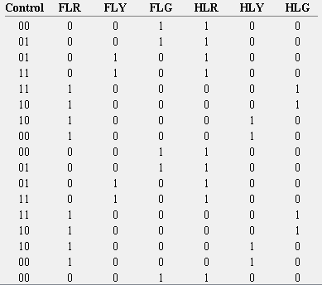

Log 1

As can be seen, there is no case where both traffic lights are green at the same time. In this particular test, the farm road light goes from green to yellow to red, and the highway light only changes to green when the other light is red and vice versa.

**Conclusion**

The lab went smoothly. The datapath was relatively simple, with no combinational logic necessary. However, I will most likely need to use both combinational and sequential logic when implementing the control unit.